

An Undergraduate Internship/Project on Official Webpage of GMS Composite and Knitting Ind. Ltd

By

**Isra Islam**

Student ID: **1610965**

Autumn, 2020

Supervisor:

**Bijoy Rahman Arif**

Lecturer

Department of Computer Science & Engineering

Independent University, Bangladesh

**June 17, 2021**

Dissertation submitted in partial fulfillment for the degree of Bachelor of Science in Computer Science

Department of Computer Science & Engineering

**Independent University, Bangladesh**

# Attestation

I hereby declare that while completing my degree at Independent University, Bangladesh, the internship report submitted is my own initial work. No material was previously published or written by a third party shall be included in the report, except where this is appropriately cited by full and accurate referencing. The report does not include material that was accepted or submitted for any other purpose.

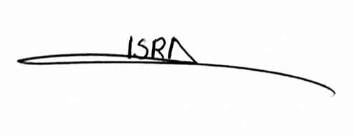

17-06-2021

Signature Date

Isra Islam

Name

# Acknowledgement

I take this opportunity to express my gratitude to the people who have been instrumental in the successful completion of this report. Any report's success depends heavily on the encouragement and guidelines of many individuals. I would like to express my gratitude to my internship supervisor Bijoy Rahman Arif for providing me the report with clear guidelines and instructions throughout my internship program. Without his help, suggestion and cooperation, this report would not have been completed successfully. Moreover, I feel fortunate to have the opportunity to work at GMS Composite and Knitting Ind. Ltd. as an Intern at their Office. I am grateful to Golam Mostafa (Managing Director) along with other members from GMS Composite and Knitting Ind. Ltd, M A Huq Shameem (Controller of Accounts), MD Rafiquzzaman (Sr. Officer, IT services) who acted as a mentor to complete my regular task and provided me with valuable information regarding this report. Finally, I am grateful to Independent University, Bangladesh (IUB), for providing this knowledgeable and wonderful internship experience as a platform.

# Letter of Transmittal

17/06/2021

Bijoy Rahman Arif

Lecturer,

Department of Computer Science and Engineering,

Independent University, Bangladesh

Subject: Letter of Transmittal for Internship Report, autumn 2020.

It’s my great pleasure to place my Internship report for your kind approval. I, ISRA ISLAM, from autumn 2020, Section 4, have completed my Internship Program and its report. I completed my internship at, GMS Composite and Knitting Ind. Ltd. which started on 1st February of 2021.

This report contains my experience and work in the company. It is my immense pleasure to presenting you with my experience in all the different technology-related fields of the company, including system monitoring, Operating Software, and Official Webpage Development. Also, get to familiar with the process and practices of development.

I hope, during the internship program, this report will reflect my learning and you will find it in order.

Sincerely,

ISRA ISLAM

1610965

# Evaluation Committee

Signature

Name

Supervisor

Signature

Name

Internal Examiner

Signature

Name

External Examiner

Signature

Name

Convener

# Abstract

My internship was at GMS Composite and Knitting Ind. Ltd., a garments manufacturing company. This company mainly deals with the export of garments worldwide. GMS COMPOSITE KNITTING IND. LTD, an entirely integrated and independent unit, comprises of state-of-the-art composite knitting, dyeing, finishing and stitching units under one roof. Our modern facilities along with our professional and dedicate team have made us what we are today – renowned and reliable exporters of quality knitted fabrics across the globe.

This report is the result of the internship conducted in GMS Composite and Knitting Ind. Ltd. I selected GMS Composite and Knitting Ind. Ltd because we are going through a pandemic it was getting difficult to get an internship so I requested the authority to consider the current situation and I got the opportunity to work in the IT department and gain practical knowledge. The aim of the project was to develop an official website for the company as the current website is not running.

Before working on any project, I had to completely understand the sole purpose of the project and what the requirements of the project are and plan my action, and work accordingly. I was assigned to create a website of Composite and Knitting Ind. Ltd containing Homepage, About Us, and Contact Us. I also had to work on the backend to get the message those who want to contact through the website.

Table of Contents

Attestation i

Acknowledgement ii

Letter of Transmittal iii

Evaluation Committee iv

Abstract v

Chapter 1: Introduction 1

1.1 Overview/Background of the Work 1

1.2 Objectives 1

1.3 Scopes 2

Chapter 2: Literature Review 3

2.1 Relationship with Undergraduate Studies 3

2.2 Related works 3

Chapter 3: Project Management & Financing 5

3.1 Work Breakdown Structure 5

3.2 Process/Activity wise Time Distribution 7

3.3 Gantt chart 7

3.4 Process/Activity wise Resource Allocation 8

3.5 Estimated Costing 9

Chapter 4: Methodology 10

4.1 Methodology Used 10

4.2 Front end Language 12

4.3 Back-End Language 12

4.4 Development Tools Used 12

4.5 Other Non-Development Tools Used 13

Chapter 5: Body of the Project 15

5.1 Work Description 15

5.2 System Analysis 15

5.2.1 Six Element Analysis 15

5.2.2 Feasibility Analysis 16

5.2.3 Problem Solution Analysis 17

5.2.4 Effect and Constraints Analysis 18

5.3 System Design 19

5.3.1 Rich Picture 19

5.3.2 UML Diagrams 19

5.3.3 Functional and Non-Functional Requirements 22

5.4 Product Features 24

5.4.1 Input 24

5.4.2 Output 25

5.4.3 Architecture 25

Chapter 6: Results & Analysis 26

Chapter 7: Project as Engineering Problem Analysis 28

7.1 Sustainability of the Project/Work 28

7.2 Social and Environmental Effects and Analysis 29

7.3 Addressing Ethics and Ethical Issues 29

Chapter 8: Future Work & Conclusion 30

8.1 Future Works 30

8.2 Conclusion 30

Bibliography 31

**List of Figures**

Figure 1: Work Breakdown Structure 5

Figure 2: Process/Activity Wise Time Distribution 7

Figure 3: Gantt chart 7

Figure 4: Process/Activity wise Resource Allocation 8

Figure 5: Estimated costing chart 9

Figure 6: Process of Waterfall Methodology 11

Figure 7: Rich Picture of www.gmsbd.com 19

Figure 8: Use case Diagram www.gmsbd.com 20

Figure 9: ERD Diagram of www.gmsbd.com 21

Figure 10: Class diagram 21

Figure 11: Contact Us page 24

Figure 12: Backend data of contact us form 24

Figure 13: Architecture MVC Model of www.gmsbd.com 25

Figure 14: website of www.gmsbd.com 26

**List of Tables**

Table 1: Estimated Costing Table 9

Table 2: Six element Analysis 16

Table 3: Functional Requirement 22

Table 4: Functional Requirement 22

Table 5: Functional Requirement 22

Table 6: Functional Requirement 23

Table 7: User test case 27

# Introduction

## Overview/Background of the Work

I have made the official webpage of GMS Knitting Ind. Ltd as my project. During my interview, I was asked about my skills so I stated that I had learned Front end web development and back-end development as well. Knowing that my employer asked if I could make an official webpage as the current webpage is not published on the Domain. I immediately said yes because in my university I have done webpage development so I knew executing the work properly. After receiving the job confirmation and working for some time I was assigned the task of creating a webpage for the company.

## Objectives

* The main objective of this work is to create a well-functioning official webpage that provides information about the company and its services to the visitor.
* There will be a contact us form to directly connect the customer to the company for direct communication. It is very important to reach out to the customers and answer their queries. In this way, we can know exactly the customers' concern and improve our production and service.
* Provide visitors brief information about the company and its services.
* The official webpage might work as a marketing medium and promote company products and services.

## Scopes

The website will have the features gives below

* Landing page
* About Us page
* Our services page
* Contact Us page

Landing Page: The landing page will have a welcome message along with the logo and slogan of the company.

About us page: The about Us page will give the visitor a brief history of the company.

Our Services Page: This section will talk about the services provided by this company.

Contact us page: This section will help visitors to directly contact the company to convey their message, opinion, or to ask for any information from the company. The admin will note down the message and get back to them.

Moreover, it has more scopes such as

* Website is an effective method to showcase the products and services provided by the company.
* Developing a site helps you to create social proof.
* It helps in branding your business.
* It helps to achieve business goals.
* It becomes easy to provide customer service.
* It also helps to gain customer trust.

# Literature Review

## Relationship with Undergraduate Studies

* CSE 309 Web Applications and Internet: This course helped me the most in this project, in this course we were taught about web application development from scratch. In this course, we were taught both Front-End web development and Back-End web development. HTML, CSS, JavaScript, Bootstrap, and PHP. Also, we had to make a project from scratch so creating the project step by step gives us the idea to execute the project properly.
* CSE 307 System Analysis and Design: In this course, we were taught how to analyze a system and design according to the requirements. This course gave me a complete insight into system development. This course has helped me to create this report. Feasibility Analysis, Functional and Non-Functional Requirements are taught in this course.
* CSE 303 Database Management: This course is also one of the important course which helped me in this project. In this course, we were taught how to plan, draw process flow diagrams, Rich pictures, six-element analysis, entity relation diagrams, Business process model and notation diagram, and most importantly SQL (Structured Query Language) to define and manipulate data.

## Related works

**MoveBD**

MoveBD is a logistics webpage service provider which helps to customer to shift from one place to another. The problem we face during shifting our goods and households is that either to take all the goods or to leave some of them or to sell them out. To handle such kind of problem the role of moved comes into action. In our country’s context shifting home is a difficult matter. Things get disorganized, lost, or even stolen so this project might help people out.

The project was developed to provide an interactive platform between clients and service providers. This project provides the best and reliable services in relocating. Clients can book the services through this web portal. This Project provides useful information to clients in the process of relocating their houses.

* It had a Registration Page, Log in Page for both Customer and Service Provider.
* Two different User Interfaces for Customers and Service Provider.

**Online Telemedicine Management System**

Corona virus's sudden outbreak was the main reason behind the creation of the project. It was suggested to stay home. People with health issues need to continue their treatment so providing healthcare service to people without leaving their homes was this project's main aim. Moreover, people with health issues are at high risk of getting infected and if they go out of their home and if they are left untreated then they might become sicker so the treatment must go on. So the service from this project was the best solution. When the coronavirus situation will be fully controlled the telemedicine service can continue its service and people can treat themselves from home by spending less amount of money without any worries.

* The project had a total of 7 stakeholders 1. Patient 2. Doctor 3. Lab admin 4. Admin 5. Developer 6. Medicine Shopkeeper 7. Driver so each of the users had a registration page, Login page, it also had user wise dedicated user interface.
* It also provided service for a sample collection from home for the pathological and covid-19 test as well.
* It had a medicine delivery service.

# Project Management & Financing

## Work Breakdown Structure

The work Breakdown Structure is given below

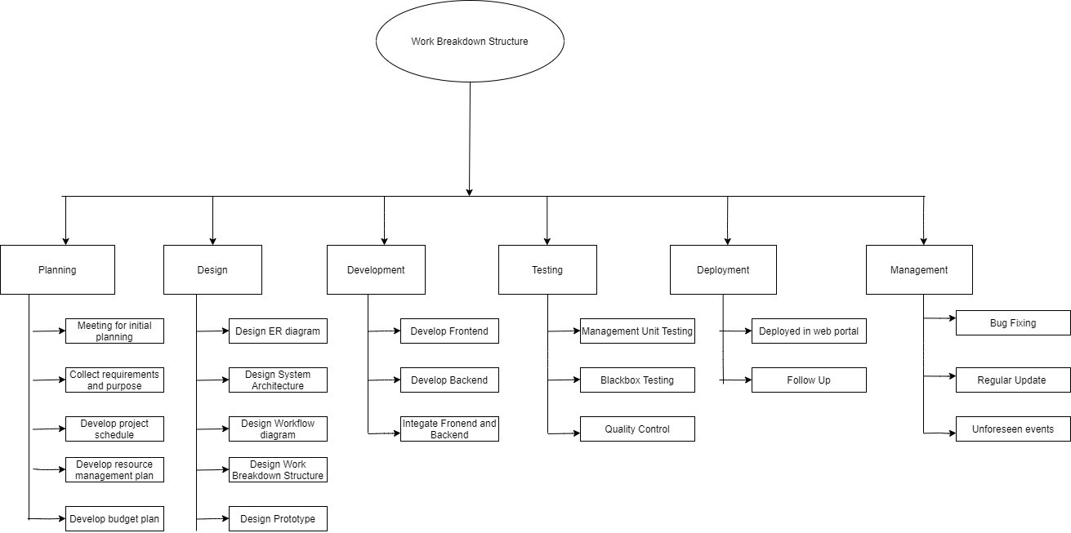

Figure 1: Work Breakdown Structure

**www.gmsbd.com**

1. Planning
   * Meeting for initial planning
   * Collect requirements and Purpose of the webpage
   * Develop project schedule
   * Develop resource management plan
   * Develop budget plan
2. Design
   * Design ER diagram
   * Design system Architecture
   * Design workflow diagram
   * Design WBS
   * Design Prototype
3. Development
   * Develop Frontend
   * Develop Backend
   * Integrate frontend and backend
4. Testing
   * Management unit testing
   * Black box testing
   * Quality control
5. Deployment
   * Deployed in web portal
   * Follow-up
6. Management
   * Bug fixes
   * Regular update
   * Unforeseen events

## Process/Activity wise Time Distribution

Process/Activity wise Time Distribution chart is given below

Figure 2: Process/Activity Wise Time Distribution

## Gantt chart

Gantt chart is a type of bar chart that illustrates a project schedule, named after its inventor, Henry Gantt, who designed such a chart around the years 1910–1915. Modern Gantt charts also show the dependency relationships between activities and the current schedule status.

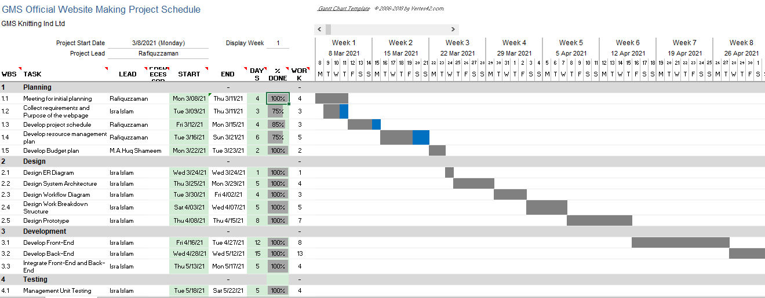

Figure 3: Gantt chart

## Process/Activity wise Resource Allocation

The Process/Activity wise Resource Allocation chart is showing that the time spend on each activities and the work percentage done the chart is given below

Figure 4: Process/Activity wise Resource Allocation

## Estimated Costing

The table shows the estimated costing from the table we could see that the Total cost is about 25000 BDT in which Development Task costs the most about 15000 BDT.

|  |  |  |
| --- | --- | --- |
| **Estimated Costing** | | |
| **Sl No** | **Tasks** | **Cost** |
| 1 | Design | 4000 |
| 2 | Development | 15000 |
| 3 | Testing | 2000 |
| 4 | Paying fees to web hosting services | 3000 |
| 5 | Management | 1000 |
| 6 | Total | 25000 |

Table 1: Estimated Costing Table

The chart shows that the total cost of the project and the amount each tasks are charging altogether.

Figure 5: Estimated costing chart

# Methodology

Website: A website is a group of globally accessible, interlinked web pages which have a single domain name. It can be developed and maintained by an individual, business, or organization. The website aims to serve a variety of purposes. Example: Blogs. A website is hosted on a single or multiple web server. It is accessible via a network like the Internet or a private local area network via IP address. Website development mainly consists of two parts front end and backend.

## Methodology Used

Methodology: The Waterfall Model was the first Process Model to be introduced. It is very simple to understand and use. In a Waterfall model, each phase must be Waterfall completed before the next phase can begin and there is no overlapping in the phases. The waterfall model is the earliest SDLC approach that was used for software development.

In “The Waterfall” (1) approach, the whole process of software development is divided into separate phases. The outcome of one phase acts as the input for the next phase sequentially. This means that any phase in the development process begins only if the previous phase is complete. The waterfall model is a sequential design process in which progress is seen as flowing steadily downwards (like a waterfall) through the phases of the cycle.

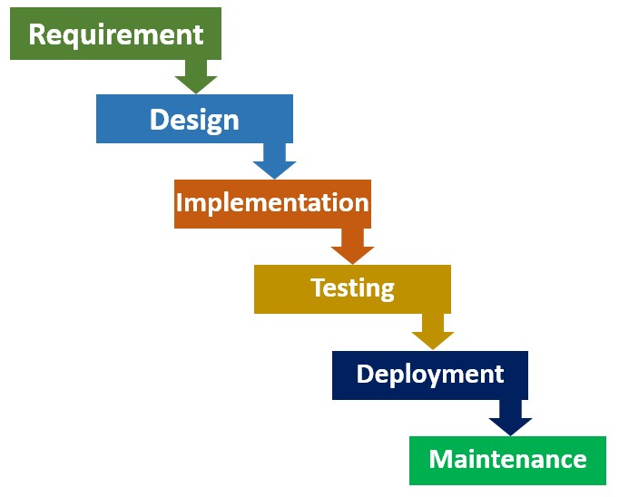

Figure 6: Process of Waterfall Methodology

* **Requirement Gathering and analysis:** At this stage, the requirements are gathered and specified and documented according to the customers' needs, and then the given requirements are analyzed by the team. The first phase involves understanding what needs to design and what is its function, purpose, etc. Here, the specifications of the input and output or the final product are studied and marked.
* **System Design:** The requirement specifications from the first phase are studied in this phase and system design is prepared. System Design helps in specifying hardware and system requirements and also helps in defining overall system architecture. The software code to be written in the next stage is created now.
* **Implementation:** The system is first created with inputs from the system design in small programs called units, which are incorporated in the next phase. For its functionality, which is referred to as Unit Testing, each unit is developed and tested.
* **Integration and Testing:** After testing each unit, all the units developed in the implementation phase are integrated into a system. The entire system is tested for any faults and failures after integration.
* **Deployment of system:** Once the functional and non-functional testing is performed, the item is deployed or released to the market in the customer environment.
* **Maintenance:** In the client setting, some issues come up. Patches are released to repair those problems. Also, some better versions will be released to improve the product. To deliver these changes in the client environment, maintenance is performed.

## Front end Language

**HTML**: HTML stands for Hypertext Markup Language. It is used to design the front-end portion of web pages using a markup language. HTML is a combination of a language called Hypertext and Markup. A link between web pages is defined by hypertext. The markup language is used to define the text document that defines the structure of the web pages within the tag. (2)

**CSS**: CSS stands for Cascading Style Sheets is a simple language designed to simplify the presentation process of web pages. CSS makes it possible for you to apply styles to web pages. Cascading Style Sheets is a style sheet language used for describing the presentation of a document written in a markup language such as HTML. CSS is a cornerstone technology of the World Wide Web, alongside HTML and JavaScript. (3)

**JAVASCRIPT**: JAVASCRIPT it is a scripting language that enables the creation of dynamically updating content, control multimedia, animate images, and dynamic contents. It is believed to create magic on websites so that the website can be interactive for the user. It is used to improve a website's functionality by running cool games and web-based software. (4)

## Back-End Language

**PHP**: is a widely-used open source general-purpose scripting language that is especially suited for web development and can be embedded into HTML. PHP is a scripting language on the server side, designed specifically for web development. Since PHP code is executed on the server-side, it is called the language of server-side scripting. (5)

## Development Tools Used

To create the website several tools were used. Let’s start with bootstrap.

**Bootstrap**: Bootstrap is a potent front-end framework used to create modern websites and web apps. It's open-source and free to use, yet features numerous HTML and CSS templates for UI interface elements such as buttons and forms. It is very easy to use and it makes the development process very seamless. (6)

**Sublime**: Sublime Text Editor is a full-featured text editor for local or code-based file editing. It includes various code base editing features that assist developers to keep track of changes. The Sublime Text editor, like Visual Studio Code and NetBeans, is used as an Integrated Development Editor (IDE). The current version of the Sublime Text editor is 3.0 and is compatible with various Windows, Linux, and MacOS operating systems.

## Other Non-Development Tools Used

There were some other tools used in the process of developing the website to have a continuous workflow, keep track of work and keep a backup. So, the first tool we were zoom to have all the meetings as we had to work from home during this pandemic.

**Zoom:** Zoom is a cloud-based service that offers Meetings and Webinars and provides content sharing and video conferencing capability. You do not need a Zoom account to attend a Zoom meeting, only the host is required to have an account to enable the scheduling of meetings. Zoom offers video, audio, and screen-sharing experience, screen controlling access across a wide range of devices and platforms.

**GitHub:** GitHub is a code hosting platform for version control and collaboration. It lets people work together on projects from anywhere. GitHub, Inc. is a provider of Internet hosting for software development and version control using Git. It offers the distributed version control and source code management (SCM) functionality of Git, plus its features. It provides access control and several collaboration features such as bug tracking, feature requests, task management, continuous integration, and wikis for every project.

GitHub offers its basic services free of charge. Free GitHub accounts are commonly used to host open-source projects. GitHub offers unlimited private repositories to all plans, including free accounts, but allowed only up to three collaborators per repository for free. (7)

We work on GitHub by the following features

* Create and use a repository
* Start and manage a new branch
* Make changes to a file and push them to GitHub as commits
* Open and merge a pull request

# Body of the Project

## Work Description

The project is mainly an official website of GMS Knitting Ind. Ltd my work was to understand what my seniors instructed me and I had to gather and visualize all the requirements and designed a prototype and show it to them and get their feedback after getting positive feedback I immediately started to work on the coding part of the project and do Front-End-Web development and was successful to make the website and then worked on the Back-End part of the project.

## System Analysis

### Six Element Analysis

|  |  |  |  |  |  |  |
| --- | --- | --- | --- | --- | --- | --- |
| **Process** | **Human** | **Non-Computing Hardware** | **Computer Hardware** | **Software** | **Database** | **Communication**  **& Network** |
| View Landing Page | Visitor | N/A | Desktop / Laptop / Tablet / Smartphone | Web Browser | MySQL | WAN / LAN |
| View Our Services | Visitor | N/A | Desktop / Laptop / Tablet / Smartphone | Web Browser | MySQL | WAN / LAN |
| View About Us | Visitor | N/A | Desktop / Laptop / Tablet / Smartphone | Web Browser | MySQL | WAN / LAN |
| Type message on Contact Us page | Visitor | N/A | Desktop / Laptop / Tablet / Smartphone | Web Browser | MySQL | WAN / LAN |
| View messages received from  Contact Us page | Concern Team | N/A | Desktop / Laptop / Tablet / Smartphone | Web Browser | MySQL | WAN / LAN |
| Reply the received message | Concern Team | N/A | Desktop / Laptop / Tablet / Smartphone | Web Browser | MySQL | WAN / LAN |

Table 2: Six element Analysis

### Feasibility Analysis

**Feasibility Study:**

* A feasibility study is used to determine the reasonability of a project. It determines whether the project is legal, technically, economically feasible, and importantly whether the project is worth investing in. It evaluates the potential of the success of the process. Four feasibility studies are considered for this project.
* Technical Feasibility: To create the website the hardware components, software, and other technical requirements needed to complete this project are available making this technically feasible.
* Economic Feasibility: It is a kind of cost-benefit analysis of the examined project, which assesses whether it is possible to implement it. To measure the economic feasibility, it is needed to do assessment and analysis of the project’s potential to support and decision-making process by objectively and rationally identifying its strengths, weakness, opportunities, and risks associated with it. Also, it consists of market analysis, economic analysis, technical and strategic analysis.
* Legal Feasibility: All the legal constraints to create and upload the website have been considered before proceeding with this project which includes data protection acts, social media laws, or zoning laws so that it does not face any legal constraints in the future.
* Scheduling Feasibility: Every project will only be successful if it is completed in the given time. In my case, the project is completed within the given time. Soon it will be deployed on the webserver and be live.

### Problem Solution Analysis

**Confusing User Journey**

**Problem**: When someone visits a site, it needs to be clear to them what you want them to do. If they find themselves on a page with no idea of where to go next, it means that your site is doing a poor job guiding them through their user journey. This will hurt your ability to convert visitors.

**Solution**: Effective internal linking, an easy-to-use navigation bar, and search function, and CTA (calls-to-action) on every page is necessary to help guide your visitors. Look at metrics such as high bounce rates to determine where there might be user journey issues on your site.

**Using a Commonly Used Theme**

**Problem**: Using pre-designed templates for the web page often results disconnect between the brand image and the website content, confusing potential customers. So this needs to be avoided. Visitors do not like to see the same things appear again and again in a different name it shows the lack of portraying creativity.

**Solution**: We can have a look at different templates and customize those according to our preference and try to connect with the brand and customer and add unique and user-friendly features.

**Slow Loading Time**

**Problem**: Slow loading times can kill the website experience of the visitors. Few people have the patience to wait more than a few seconds for a page to load--especially when they’ve become so accustomed to how quickly other high-quality websites load. If your site won’t load, they can find a site that will. Generally speaking, the majority of visitors will expect the page to load within two seconds.

**Solution**: The easiest way to improve the loading speed of your website is by compressing all of the CSS documents, HTML documents, and JavaScript documents and by setting up CSS and JavaScript in external files. We need to optimize the back-end of the website so that it will load faster.

**Mobile Incompatibility**

**Problem**: If the website isn’t mobile-friendly, it will affect how it’s displayed on mobile devices. If the site doesn’t display properly, load quickly (or at all), or is difficult to navigate on mobile devices, we will lose a massive number of potential leads.

**Solution**: We have kept the matter in mind and so we have ensured mobile optimization by using Bootstrap for responsive website design. Responsive design ensures that your site will display properly no matter how big or small the screen is.

**Cluttered Homepage**

**Problem**: Homepage is the introduction to not just the website, but to the business. As such, we need to make sure it leaves a good first impression on new visitors. One of the more common mistakes businesses make on their homepage is trying to present too much information. This causes it to become cluttered. A cluttered homepage can be overwhelming and difficult to read, making it hard for visitors to find what they’re looking for.

**Solution**: We have kept the UI simple excluding unnecessary information and design.

### Effect and Constraints Analysis

**Effects**The Company’s old website was not maintained properly. It was not live on the server. The old website was very basic. Moreover, it did not have any contact us form so the visitors could not connect directly with the company. All sort of communications was done in Mobile phone and there was no saved record so the problems were not being able to identify and take appropriate measures.

**Constraints**There were problems while creating the website I was having an issue with the backend the data was not being saved so I had to find out the issue and make sure all the data was being saved.

## System Design

### Rich Picture

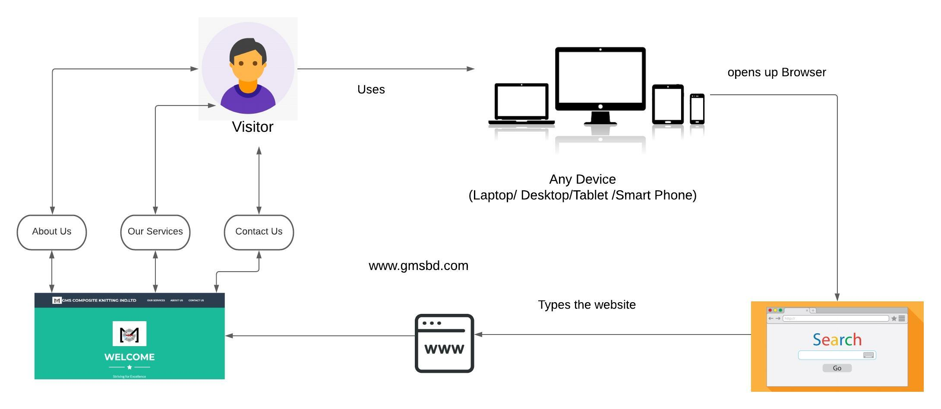

Figure 7: Rich Picture of [www.gmsbd.com](http://www.gmsbd.com)

### UML Diagrams

**Use Case Diagram**

A UML diagram is a diagram based on the UML (Unified Modeling Language) to visually represent a system along with its main actors, roles, actions, artifacts or classes, to better understand, alter, maintain, or document information about the system.

In this diagram www.gms.bd is a system there are two actors Visitor and Admin (Company Employee). A visitor enters into the system they will be able to see Landing Page, About Us Page, Our Services, and Contact Us Page. The visitor will also be able to send their message and contact the company directly using the Contact Us page. The message will be seen by the Admin and he/she will contact the visitor and provide assistance.

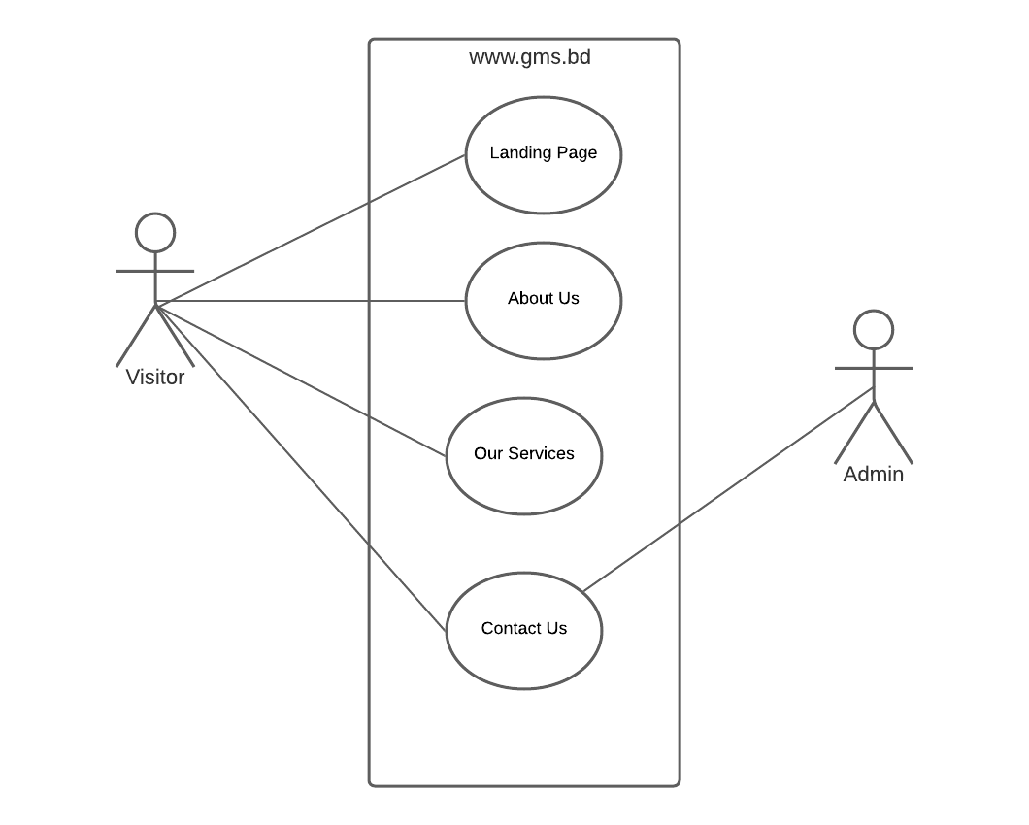

Figure 8: Use case Diagram [www.gmsbd.com](http://www.gmsbd.com)

**ERD Diagram**

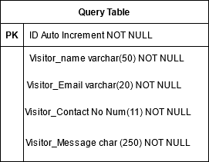

Figure 9: ERD Diagram of [www.gmsbd.com](http://www.gmsbd.com)

**Class diagram**

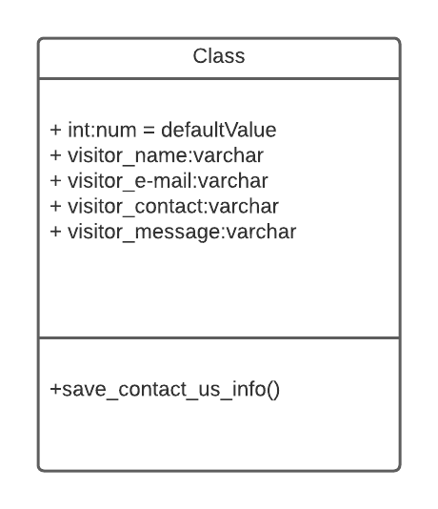

Figure 10: Class diagram

### Functional and Non-Functional Requirements

Functional Requirements

|  |  |  |
| --- | --- | --- |
| **Function**: Visitor will be able to view About Us page. | | |
| **Input:** N/A | **Process**: Visitor will have to type [www.gmsbd.com](http://www.gmsbd.com) on browser and click on About Us option | **Output**: About Us page will appear. |
| **Precondition**: Visitor must have an active internet connection. | | |
| **Post condition**: User should be on [www.gmsbd.com](http://www.gmsbd.com) | | |

Table 3: Functional Requirement

|  |  |  |
| --- | --- | --- |
| **Function**: Visitor will be able to view Our Services page. | | |
| **Input:** N/A | **Process**: Visitor will have to type [www.gmsbd.com](http://www.gmsbd.com) on browser and click on Our Services option. | **Output**: Our Services page will appear. |
| **Precondition**: Visitor must have an active internet connection. | | |
| **Post condition**: Visitor should be on [www.gmsbd.com](http://www.gmsbd.com) | | |

Table 4: Functional Requirement

|  |  |  |
| --- | --- | --- |
| **Function: Visitor will be able to view Contact Us page.** | | |
| **Input:** N/A | **Process**: Visitor will have to type [www.gmsbd.com](http://www.gmsbd.com) on browser and click on Contact Us option. | **Output**: Contact Us page will appear. |
| **Precondition**: Visitor must have an active internet connection | | |
| **Post condition**: Visitor should be on [www.gmsbd.com](http://www.gmsbd.com) | | |

Table 5: Functional Requirement

|  |  |  |
| --- | --- | --- |
| **Function**: Visitor will be able to write and send message Contact Us page. | | |
| **Input:** Name, Email, Contact, Message. | **Process**: Visitor will have to type [www.gmsbd.com](http://www.gmsbd.com) on browser and click on Contact Us page and type and send their message. | **Output**: Visitor will be able to write and send the message to the company database. |
| **Precondition**: Visitor must have an active internet connection. | | |
| **Post condition**: Visitor should be on [www.gmsbd.com](http://www.gmsbd.com) | | |

Table 6: Functional Requirement

**Non-Functional Requirements**

Non-functional requirements are given below

* Good User-Interface: The software should have a good user interface so that users can easily use the system
* Responsive: It should fit in different types of device
* Response time: it should take very little time to respond to the users’ request
* Interoperability the system should be able to with other systems at present, in the future in either implementation or access, without any restrictions.
* Extensibility of new services and features could be added to the system.
* Fault tolerance the system should be able to work on when one or more of the components fail
* Maintainability: the system should be maintained easily
* Performance Response Time, Throughput, Utilization, Static Volumetric these all features should be maintained properly by the system
* Response Time: The system provides acknowledgment in just one second once the 'patient's information is checked.
* Back-Up: The system should offer efficiency for data backup.
* Availability: The system is available all the time.

## Product Features

### Input

The contact us have total four fields along with a send button. The fields are defined on the ERD Diagram and the visitor will be able to send their message though this Contact Us form.

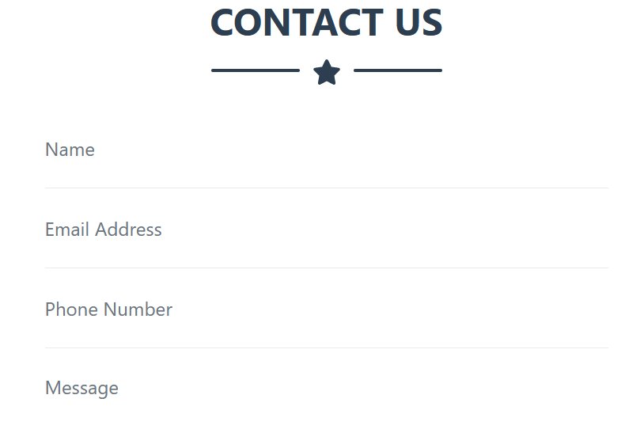

Figure 11: Contact Us page

The data entered in the Contact Us form is saved on local host PHP My admin and the table given here is used to save the data.

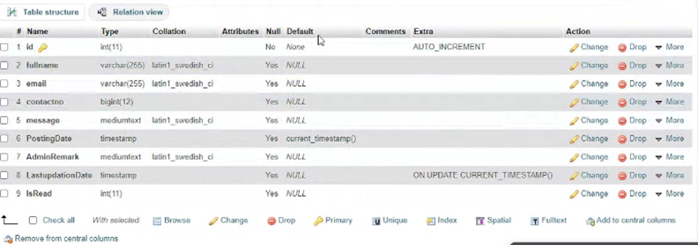

Figure 12: Backend data of contact us form

### Output

The input data of contact us can be stored and it can be viewed by the Admin.

### Architecture

Model view controller pattern is used to create this website, this model is separated into three parts model, view, and controller. In model view all data-related logics are executed, in the view model all the UI logic is run for example text boxes, buttons that the user interacts with, and lastly controller, this model creates the connection between model and view model.

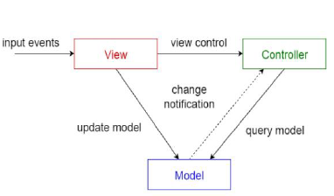

Figure 13: Architecture MVC Model of [www.gmsbd.com](http://www.gmsbd.com)

# Results & Analysis

The screenshots of the website is given below.

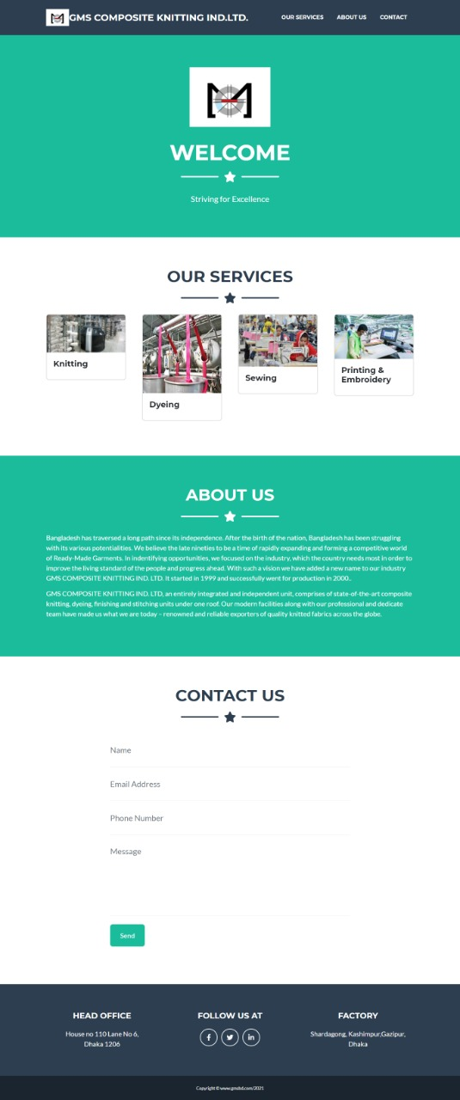

Figure 14: website of [www.gmsbd.com](http://www.gmsbd.com)

To analyze the project, I decided to create a test case write down all the possible test cases and do a manual testing and look for an error. If an error is found I needed to write down and find out the error and work on fixing the error. While working on this project I had created the test case and did manual testing and noted down all the problems. I am showing the use test case table used for testing.

|  |  |  |  |  |  |  |
| --- | --- | --- | --- | --- | --- | --- |
| **Test Case Number** | **Test Case Name/Title** | **Description** | **Expected Result** | **Actual Result** | **Test results** | **Defect ID** |
| 1 | Enter into www.gms.bd | Visitor will be able to enter the website | Visitor will be able to enter the website successfully | Not being able to do as it is not live in server | Failed | D01 |
| 2 | Click and view About Us page | Visitor will be able to click and  view About Us page | Visitor will be able to click and  view About Us page successfully and About Us page will appear | Visitor is being able to click and  view About Us page successfully and About Us page is appearing | Pass |  |

Table 7: User test case

# Project as Engineering Problem Analysis

## Sustainability of the Project/Work

A project is called sustainable when a continued utilization of its results can be assured after the completion of the project.

Data Optimization to reduce data size: Data size and data input have been kept in check all the time so that data doesn’t become a burden and cause a problem in loading time and energy consumption. Moreover, users can input a maximum of three issues at once to keep the data size in control and keep it flexible.

Site Navigation: We have kept the website as simple as possible so that users do not find it difficult to use the website. So they do not need to click around the website and easily find the required information.

Eco-Friendly Website Design: Studies have shown that users prefer less complicated websites so keeping this concept in mind I have added necessary things only and implemented fewer JavaScript widgets, reducing the number of images.

1. Optimize images to reduce file size.
2. Be strategic with videos.
3. Use lazy load for images and media.
4. Set up web caching.
5. Delete what you don't need.
6. Improve site navigation to make it easy to find information.
7. Use a green web host.

## Social and Environmental Effects and Analysis

Social Effect: Our Company has always been worked for social reasons and from the website, a visitor could get to know the company’s involvement in various social activities. This company promotes women empowerment from head office to the factory every department has lady officers and workers where they are working in a safe environment. While visiting this website the visitor will have a clear idea about the social works done by the company.

Environmental Effect: The website creation does not affect any environmental aspects we have made sure that we are not changing the domain name and address of the website so that we can eliminate taking extra space for physical servers and also we have chosen a green host as their servers are powered by renewable energy, the companies make use of energy use offsets, and adhere to other environmentally-conscious practices. We have opted for an eco-friendly Website Design that contains fewer images and JavaScript widgets and only added necessary contents to the website.

## Addressing Ethics and Ethical Issues

Ethics is the consider of esteem concepts such as ‘good,’ ‘bad,’ ‘right,’ ‘wrong’, ‘ought’, connected to activities in connection to bunch standards and rules. The official website does not hold any ethical hazard. The contact our data is collected from the visitors to keep track of the issues and make sure the information is kept to admin only. We have also ensured Data Security Only I will have access to the server and the database system. The database is secured with user name and password, without this logging information no, one else can have access to the data collection.

# Future Work & Conclusion

## Future Works

Our future plan is to add up a section named career so that candidates looking for a job can easily apply to us and we can directly recruit. We are also planning to add more information about the company’s products and services. Moreover, the provided social media links will also be regularly monitored by a social media manager to provide the latest update of the company.

Our company is also thinking of defining creating our own Inventory Management System and Supplier Management System soon we are going to make the decision and work in these projects.

## Conclusion

My contribution in this project was to work on Front-end and Back-end and I have taken every necessary step to finish my task in the given time. In these three months, I have obtained a lot of experience and knowledge from GMS Composite and Knitting Ind. Ltd. Now I know about designing a website from scratch and also working on the backend. I have also gained experience by working in a team, I have seen myself growing immensely in these three months and I am glad that this experience was positive and I learned a lot of new things and enjoyed my time working with GMS Composite and Knitting Ind. Ltd.

# Bibliography

(1) Balaji, S., and M. Sundararajan Murugaiyan. "Waterfall vs. V-Model vs. Agile: A comparative study on SDLC." *International Journal of Information Technology and Business Management* 2.1 (2012): 26-30.

(2) Musciano, Chuck, and Bill Kennedy. *HTML & XHTML: The Definitive Guide: The Definitive Guide*. " O'Reilly Media, Inc.", 2002.

(3) Nixon, Robin. *Learning PHP, MySQL & JavaScript: With jQuery, CSS & HTML5*. " O'Reilly Media, Inc.", 2014.

(4) Crockford, Douglas. *JavaScript: The Good Parts: The Good Parts*. " O'Reilly Media, Inc.", 2008.

(5) Welling, Luke, and Laura Thomson. *PHP and MySQL Web development*. Sams Publishing, 2003.

(6)

Bacinger, T. (2015). Retrieved from toptal: https://www.toptal.com/front-end/what-is-bootstrap-a-short-tutorial-on-the-what-why-and-how

(7) (2021, May 28). Retrieved from kinsta: https://kinsta.com/knowledgebase/what-is-github/